Project Design Phase: Solution Architecture Document
C) Solution Architecture Document
The system follows a layered Business Intelligence architecture consisting of:
1. Source Layer: CSV flat files (Cheapest Cars, ElectricCarData, EVIndia, Charger list).
2. Database Layer: MySQL Workbench database `ev_analysis` running SQL cleanup.
3. Analytics Layer: Packaged Hyper extracts and calculated fields (LOD segment average).
4. Visualization Layer: 23 worksheets rendering range, efficiency, and infrastructure maps.
5. Presentation Layer: 8 integrated Tableau dashboards and narrative story views.

System Flow Diagram
Raw CSVs -> MySQL DB -> SQL Prep -> Export CSVs -> Tableau Hyper -> Calculated Fields -> Worksheets -> Dashboards -> Tableau Public -> Web Hub
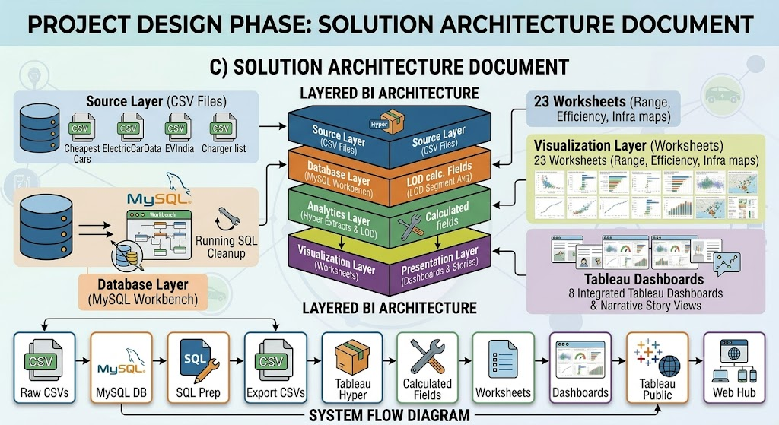
System Architecture Topology Reference